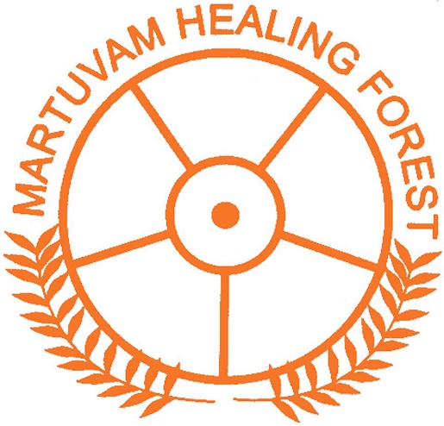 |  | The Martuvam Healing Center, located on the green belt in the north of Auroville, aims to focus on the sacred techniques of Siddha medicine.  This place is centered on the philosophy of community and giving. It is a sacred space that integrates indigenous herbal remedies with Siddha science to improve health outcomes.  The goal of this center is to support the use of herbal medicine by making indigenous medicinal plants available for distribution and home use.  Through seminars, workshops, classes and demonstrations its role is to educate the younger members of the community (students) about traditional medicine according to Siddha science.  We are committed to completing the construction of the health center as soon as possible in order to benefit our community.  However, at this very special time, our project is currently facing financial difficulties that prevent us from completing this mission. Therefore, we are now looking for generous donors who would like to offer us their help.  If you share the same values as those of our project, do not hesitate to help us  .  Our current need is estimated at 1.235.900 rupees  or 14,497 (fourteen thousand four hundred and ninety-seven euros) or $16,437 (sixteen thousand four hundred and thirty-seven US dollars), budget that you will find in the attachment  However, any participation, however small, would be precious for our association.  Thanks to your collaboration, you will contribute to the community being able to quickly benefit from this health center and all its advantages.

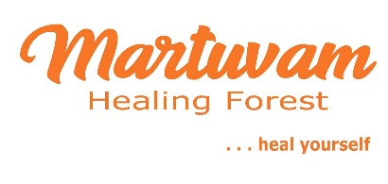

CONTACT
Phone :
Shivaraj
(+91)93454 54232

Lien Internet :
https://auroville.org/contents/189

E-MAIL :
martuvam@auroville.org.in
sivaraj@auroville.org.in

