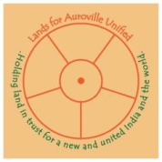
Lands for Auroville Unified (LFAU)
Auroville Centre for Urban Research, Administrative Area, Auroville – 605101, Tamil Nadu, India

24th April 2022

Today, 102 years ago, a vastly significant event took place from the perspective of creation of a new world, and a new India – the Mother’s permanent return to Pondicherry. A line from Savitri sums it up: “The united two begun a greater age.” The reference, of course, is to the collaboration between the Mother and Sri Aurobindo.
A question was put to the Mother: “Sweet Mother, How should I prepare myself for the April 24th Darshan?” She replied:
“Look attentively into yourself to find out what for you is the most important thing, the thing you feel that you couldn’t do without. It is an interesting discovery.”
This answer from The Mother calls for consulting our conscience to find out what is most important thing in our individual lives. It is a summons to be alone with our own highest aspirations, with God or, if you don’t relate to the idea of God, with one’s North Star, one’s goal in life.
To consult one’s conscience, to find out what is the most important thing in life, becomes easy with the growth of what Sri Aurobindo and The Mother called the psychic being, our true divine individuality. Then, one has the right indications, has the right thoughts, feelings, attitudes in everything. With the growth the psychic being, our ability to see the “right” and our firmness to follow the “right” increases.
One of the reasons for the creation and existence of Auroville is to facilitate the discovery of the psychic being: to create a collective environment for individuals to follow the indications coming from the psychic being, and to learn to live in the light of the psychic being, with its peace, purity and strength to guide our lives.
Our campaign “Acres for Auroville” was born and is carried on the wings of conscience: we are convinced it is the right thing to safeguard and protect the planned area for the emergence of a city that can be the world’s North Star. We believe that your goodwill and collaboration, too, is carried on the wings of the same voice of conscience. Collectively, we can aspire and together try to do our best. The rest is in the hands of the animating Force that carries Auroville onward, and will continue to carry Auroville onward for centuries to come.
With trust in Auroville’s bright future,
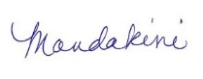
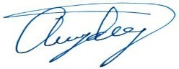

Aryadeep Mandakini

Please specify your donations for “ACRES FOR AUROVILLE” via check, bank transfer or online.
Donating & Tax Deductibility information: https://land.auroville.org/new-banking-information/
News, videos, and land information: www.land.auroville.org
Contact: +91-413-2622657 lfau@auroville.org.in

