The French Pavilion presents the documentary:

«Voltaire ou la liberté de penser »
Directed by Stéphane Bern

Saturday, 9 November 2019 at 5 pm, Town Hall - Cinema Paradiso

in French only; duration: 110 mn

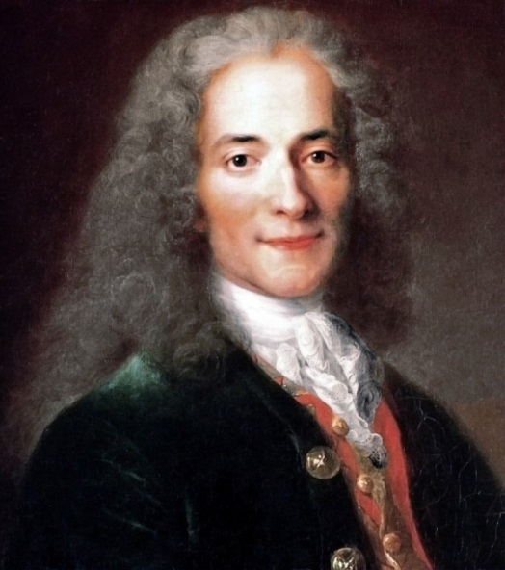

"Voltaire or the freedom to think"
The life of a giant of our cultural heritage

Voltaire was born in 1694 into a family of notaries and died in 1778 in Paris.

He is the intellectual who best embodies the Age of Enlightenment. We follow the footsteps of François-Marie Arouet, alias Voltaire, from England to the Château de Versailles, from the Palais de Sans-Souci, near Berlin, to the Château de Cirey, cradle of his love with Émilie du Châtelet, to his refuge in Ferney. Not to mention the Pantheon, where he the oldest "Great Man" buried there.

The documentary draws a parallel between the author of the famous slogan against religion: "Let us crush the infamous one!", and his elevation (in his lifetime!) to the rank of idol of letters and ideas. Voltaire, Pope of free thought, became a kind of republican saint in 1791: it was for him that the revolutionaries transformed the church of Sainte-Geneviève into the Pantheon in Paris.
His irony and his ferocity towards power earned him a few visits to the Bastille. "One man alone can sometimes change the world with his pen."
Pantheonized in July 1791, this hero of the Republic is an integral part of our intellectual and literary heritage.

